

Memebers : Talha Faheem and Daniyal Hikmat
BSSE(B) Semester 4
Subject: DATABASE (Lab)

Multi-Vendor E-Commerce Platform with Customer and Seller Management System

Milestone | Version | Date | Remarks
ERD & DB Schema | 1.0 | 26-04-2026

ERD :
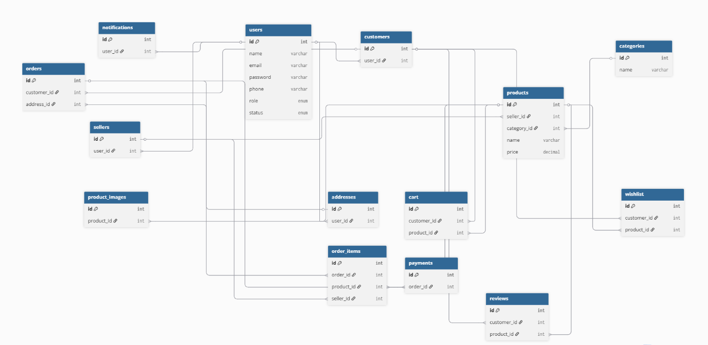

Schema Description:
USERS Table
Attribute | Data Type | Key | Description
id | INT | PK | Unique user ID
name | VARCHAR(100) |  | User name
email | VARCHAR(150) | UNIQUE | Email
password | VARCHAR(255) |  | Password
phone | VARCHAR(20) |  | Phone
profile_image | VARCHAR(255) |  | Image
role | ENUM |  | Role
status | ENUM |  | Status
last_login | TIMESTAMP |  | Last login
created_at | TIMESTAMP |  | Created
updated_at | TIMESTAMP |  | Updated
SELLERS Table
Attribute | Data Type | Key | Description
id | INT | PK | Seller ID
user_id | INT | FK | User reference
shop_name | VARCHAR(150) |  | Shop name
shop_logo | VARCHAR(255) |  | Logo
shop_banner | VARCHAR(255) |  | Banner
shop_description | TEXT |  | Description
cnic | VARCHAR(30) |  | CNIC
bank_name | VARCHAR(100) |  | Bank
bank_account_number | VARCHAR(100) |  | Account
is_verified | BOOLEAN |  | Verified
rating | DECIMAL |  | Rating
total_sales | INT |  | Sales
CUSTOMERS Table
Attribute | Data Type | Key | Description
id | INT | PK | Customer ID
user_id | INT | FK | User reference
loyalty_points | INT |  | Points
total_orders | INT |  | Orders
wishlist_count | INT |  | Wishlist
CATEGORIES Table
Attribute | Data Type | Key | Description
id | INT | PK | Category ID
name | VARCHAR(100) |  | Name
slug | VARCHAR(150) | UNIQUE | Slug
image | VARCHAR(255) |  | Image
description | TEXT |  | Description
status | ENUM |  | Status
PRODUCTS Table
Attribute | Data Type | Key | Description
id | INT | PK | Product ID
seller_id | INT | FK | Seller
category_id | INT | FK | Category
name | VARCHAR(150) |  | Name
slug | VARCHAR(200) | UNIQUE | Slug
description | TEXT |  | Description
price | DECIMAL |  | Price
discount_price | DECIMAL |  | Discount
stock | INT |  | Stock
sku | VARCHAR(100) | UNIQUE | SKU
thumbnail | VARCHAR(255) |  | Image
status | ENUM |  | Status
average_rating | DECIMAL |  | Rating
total_reviews | INT |  | Reviews
PRODUCT_IMAGES Table
Attribute | Data Type | Key | Description
id | INT | PK | Image ID
product_id | INT | FK | Product
image_url | VARCHAR(255) |  | URL
ADDRESSES Table
Attribute | Data Type | Key | Description
id | INT | PK | Address ID
user_id | INT | FK | User
full_name | VARCHAR(100) |  | Name
phone | VARCHAR(20) |  | Phone
country | VARCHAR(100) |  | Country
province | VARCHAR(100) |  | Province
city | VARCHAR(100) |  | City
postal_code | VARCHAR(20) |  | Postal
address_line_1 | VARCHAR(255) |  | Address
address_line_2 | VARCHAR(255) |  | Optional
landmark | VARCHAR(255) |  | Landmark
address_type | ENUM |  | Type
CART Table
Attribute | Data Type | Key | Description
id | INT | PK | Cart ID
customer_id | INT | FK | Customer
product_id | INT | FK | Product
quantity | INT |  | Qty
WISHLIST Table
Attribute | Data Type | Key | Description
id | INT | PK | Wishlist ID
customer_id | INT | FK | Customer
product_id | INT | FK | Product
ORDERS Table
Attribute | Data Type | Key | Description
id | INT | PK | Order ID
customer_id | INT | FK | Customer
address_id | INT | FK | Address
order_number | VARCHAR(100) | UNIQUE | Order no
subtotal | DECIMAL |  | Subtotal
shipping_fee | DECIMAL |  | Shipping
tax | DECIMAL |  | Tax
discount | DECIMAL |  | Discount
total_amount | DECIMAL |  | Total
payment_method | ENUM |  | Method
payment_status | ENUM |  | Status
order_status | ENUM |  | Order status
ORDER_ITEMS Table
Attribute | Data Type | Key | Description
id | INT | PK | Item ID
order_id | INT | FK | Order
product_id | INT | FK | Product
seller_id | INT | FK | Seller
quantity | INT |  | Qty
price | DECIMAL |  | Price
subtotal | DECIMAL |  | Subtotal
PAYMENTS Table
Attribute | Data Type | Key | Description
id | INT | PK | Payment ID
order_id | INT | FK | Order
transaction_id | VARCHAR(150) | UNIQUE | Transaction
payment_method | ENUM |  | Method
amount | DECIMAL |  | Amount
payment_status | ENUM |  | Status
REVIEWS Table
Attribute | Data Type | Key | Description
id | INT | PK | Review ID
customer_id | INT | FK | Customer
product_id | INT | FK | Product
rating | INT |  | 1-5
comment | TEXT |  | Comment
NOTIFICATIONS Table
Attribute | Data Type | Key | Description
id | INT | PK | Notification ID
user_id | INT | FK | User
title | VARCHAR(255) |  | Title
message | TEXT |  | Message
type | ENUM |  | Type
is_read | BOOLEAN |  | Read

